**FPT ACADEMY INTERNATIONAL**



## FPT – APTECH COMPUTER EDUCATION

**Nexus Aquarium**

|  |  |  |  |
| --- | --- | --- | --- |
| **Center Name** | | FPT – Aptech – HCM2  Address: 590 Cach Mang Thang 8, District 3, Ho Chi Minh City | |
| **Instructor** |  | Ms. Le Mong Thuy |  |
| **Class** |  | T1.2302.E1 |  |
| **Group** |  | 4 |  |
| **Group members** | | **Name** | **Student ID** |
|  |  | Phan Van Giu | Student1445761 |
|  |  | Nguyen Thanh Nhan | Student1445763 |
|  |  |  |  |
| **Duration** | Start date | 23th May 2023 |  |
| End date | 23th June 2023 |  |

**This is to certify that**

**Mr.:**

Phan Van Giu

Nguyen Thanh Nhan

**has successfully designed & developed**

eProject: Nexus Aquarium website

**Submitted by:**

Phan Van Giu

**Date of issue:**

**Authorized Signature:**

**TABLE OF CONTENTS**

****FPT – APTECH COMPUTER EDUCATION 1****

****TABLE OF CONTENTS**** ****2****

****ACKNOWLEGMENT**** ****3****

****SYNOPSIS**** ****3****

****PROBLEM DEFINITION**** ****3****

****CUSTOMER'S REQUIREMENTS SPECIFICATIONS (CRS) 4****

****Business/Project Objective**** ****4****

****Hardware/ Software Requirements**** ****5****

****SCOPE OF THE WORK (IN BRIEF) 6****

****Architecture and design of the system 7****

****Diagram of the website 8****

****TASK SHEET REVIEW 1 9****

****SITE MAP 10****

****MOCK OF THE WEBSITE 1********1****

***1. Home 1******1***

***2. Gallery 1******2***

***3. Events 1******3***

***4. Booking 1******4***

***5. Feedback 1******5***

***6. Contact Us 1******6***

****TASK SHEET REVIEW 2 18****

WEBSITE DESCRIPTION ****1********9****

JAVASCRIPT DESCRIPTION ****22****

TASK SHEET REVIEW 3 ****26****

# ACKNOWLEGMENT

On behalf of team members. I would like to thank everyone who supported my team to successfully complete this eProject report. Especially, our teacher, she has supported us a lot since we started studying at FPT Aptect. With this eProject, she guided us very meticulously, enthusiastically and strictly. With her guidance, we were able to successfully complete this project. Besides, I also want to thank all the team members, each of whom worked hard to complete the eProject in earnest during the month of working together. Finally, our group would like to say thank you to my classmates and family for sharing and creating for the group the best environment to focus on the project, motivating the members to achieve their goals.

# SYNOPSIS

# The goal of the eProject is that we need to create a website that meets all the requirements of the client, Nexus Aquarium. The website showcases our distinctive logo and captivating images of the amazing sea creatures that Nexus Aquarium calls home. You can easily navigate through a user-friendly menu to explore different sections, such as the beautiful Gallery, where you can admire stunning photographs and videos of marine species. Discover detailed information and categorization of marine life species conveniently presented in a table format. Easily find information about events specifically designed for children and school events. Contacting us is easy through our dedicated Contact page, which includes phone and email details. Plan your visit by checking our website for the aquarium's location and operating hours.

# PROBLEM DEFINITION

The Web site is to be created based on the following requirements.

1. The Home page must have well defined logo and image of the sea creatures.
2. Apart from home link, other links such as gallery section, certain information about animals (marine life animals) they have.
3. Contact details must be added.
4. Timing and location must be stated in the website
5. Events (separately for children) must be stated in the website with the proper schedule and details.
6. Online booking of event (Dummy page where information must be entered, and validation checking must be done)
7. Images of the aquarium location (site seeing must be included)
8. Navigation must be maintained smooth.
9. Color combination must be precise and uniformity must be maintained.
10. Categorization of the marine life animals and there different species information should be shown in tabular form.
11. Feedback form (dummy) should be provided.

# CUSTOMER'S REQUIREMENTS SPECIFICATIONS (CRS)

**Client: Nexus Aquarium**

### Business/Project Objective:

The company advertises by distributing the pamphlets, advertising on television and so on. Due to rapid development in internet field, the company decides to launch a website where people will get all the information about the various products available with them easily.

You are supposed to create a website for them with the below mentioned requirement specifications:

* Develop a website that provides easy and convenient access to information about the company's various products.
* Increase the accessibility of information to customers through the website, thereby improving conversion rates and sales.
* Utilize the benefits of the internet and new technologies such as HTML5, JavaScript, and Geolocation to create a modern and interactive website.
* Ensure compatibility across popular browsers such as Chrome, IE, Firefox, etc., in order to expand the website's reach.
* Create a good user experience with easy information search and quick display of company products.
* Enhance brand recognition and establish an online channel for communication with existing and potential customers.

**Input to the system:**

- Input your information in the booking form

- Feedback about the quality of products

- Search for marine species.

- Search for information on ticket prices and operating hours.

**Output from the system:**

- Display special information about fish species.

- Display information about operating hours, opening days, and ticket sales hours.

- Introduce the company and provide the company's location.

* Customers can download images and information of different groups of organisms
* Output a notification upon successful registration or feedback submission.
* Display the navigation bar smoothly.

**Process**:

* + - * Validate data input from users.

**Expected delivery date:** 23-June-2023.

**List of deliverables:**

- Document Word, PDF.

- User Guide.

- Source code.

### Hardware/ Software Requirements:

* **For developer**

**Hardware**

* + Intel Pentium 4 processor or higher
  + 01 Gigabytes of RAM or higher

**Software**

* + Windows 7 OS or higher
  + Adobe Dreamweaver
  + Web browsers such as IE, Chrome or Firefox are supporting HTML5, CSS3 and Javascript.
* **For web users**

**Hardware**

* + Intel Pentium 4 processor or higher
  + 512 Megabytes of RAM or higher

**Software**

* + Windows XP OS or higher
  + Web browsers such as IE, Chrome or Firefox are supporting HTML5, CSS3 and Javascript.

# SCOPE OF THE WORK (IN BRIEF)

After a long and detailed discussion, our group has decided to create a website contain the following webpages:

1. ***Homepage***: The homepage features a logo, a search bar to search for different species of marine creatures, displays images of various marine species, and introduces Nexus Aquarium.
2. ***Gallery***: Displays detailed images and information about various types of marine organisms. They are categorized in a table format to help viewers easily identify them
3. ***Event***: The website showcases information about events specifically designed for children. It provides details about various activities, workshops, and programs tailored to engage and entertain young participants. Parents and guardians can find comprehensive information about upcoming events, including dates, venues, and registration details, ensuring a fun and enriching experience for children.
4. ***Booking***: There is a form for customers to book tickets by selecting the date, time, and quantity of tickets.
5. ***Feedback***: There is a feedback form available for customers to provide their opinions and evaluations about the services of Nexus Aquarium.
6. ***Contact Us***: Display the address of the company, Map and allow customers to request any information they want to Nexus Aquarium. Display the information of the company, clients’ review and about us.

# ARCHITECTURE AND DESIGN OF THE SYSTEM

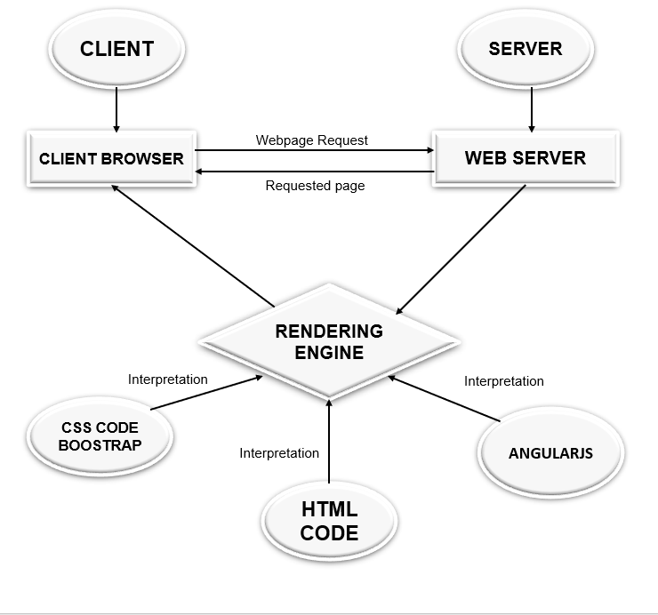

# DIAGRAM OF THE WEBSITE

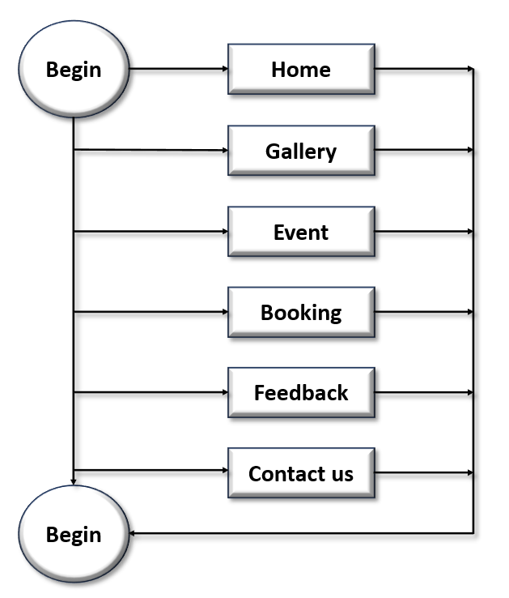



# TASK SHEET REVIEW 1

|  |  |  |  |  |  |  |  |
| --- | --- | --- | --- | --- | --- | --- | --- |
| **Project Ref. No.:**  **eP/Advertisement Portal Management**  **System/01** | | **Project Title:** | **Activity Plan Prepared By:** | **Date of Preparation of Activity Plan:** | | | |
| **Sr.**  **No.** | **Task** | **Actual**  **Start**  **Date** | **Actual Days** | **Team**  **Mate Names** | **Status** |
| 1 | Problem Statement | NEXUS AQUARIUM | Giu | 27-May-23 | 1 | Giu | Completed |
| 2 | Analysis of Nexus Aquarium requirements about the website | 27-May-23 | 1 | Giu | Completed |
| 3 | The scope of the work (in brief) | 27-May-23 | 1 | Nhan | Completed |
| 4 | Architecture and design of the system | 27-May-23 | 1 | Giu | Completed |
| 5 | Diagram of the website | 27-May-23 | 1 | Nhan | Completed |
| 6 | Task Sheet | 27-May-23 | 1 | Nhan | Completed |

|  |  |
| --- | --- |
| **Date:** | |
| Signature of Instructor:  **Ms. Le Mong Thuy** | Signature of Team Leader:  **Phan Van Giu** |

# SITE MAP

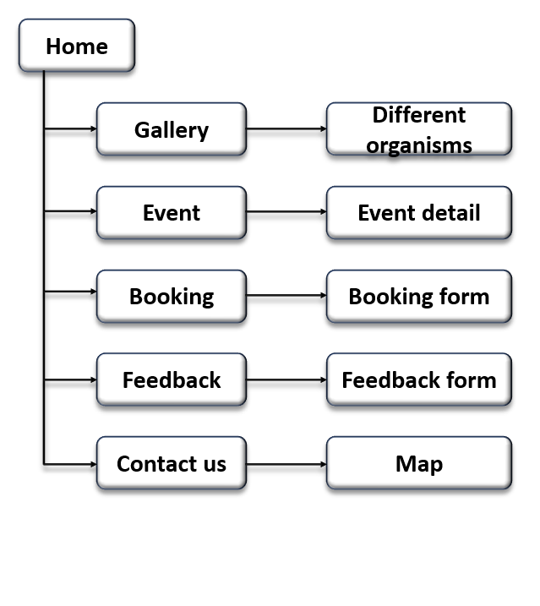

# MOCK OF THE WEB SITE

1. **Home**

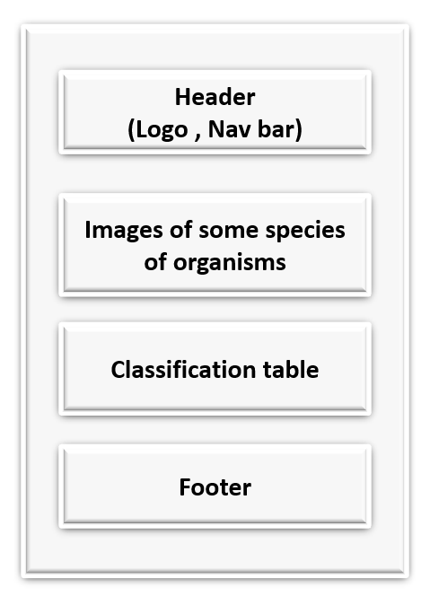

1. **Gallery**

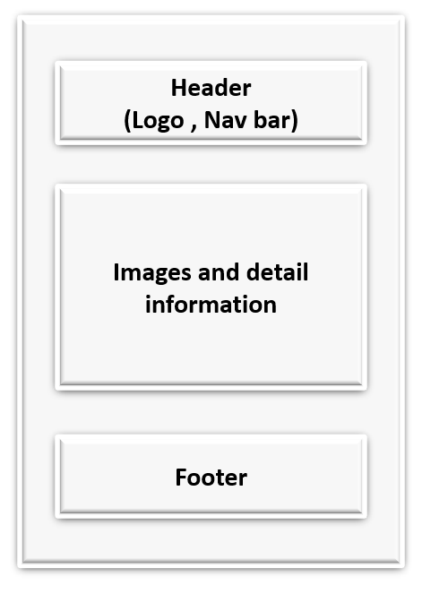

1. **Event**

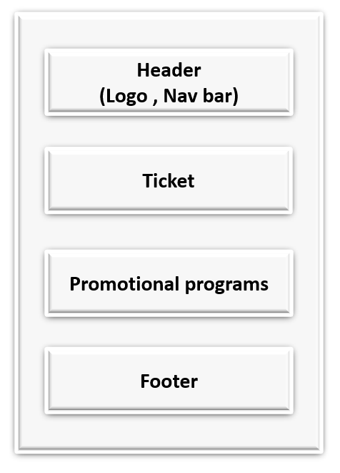

1. **Booking**

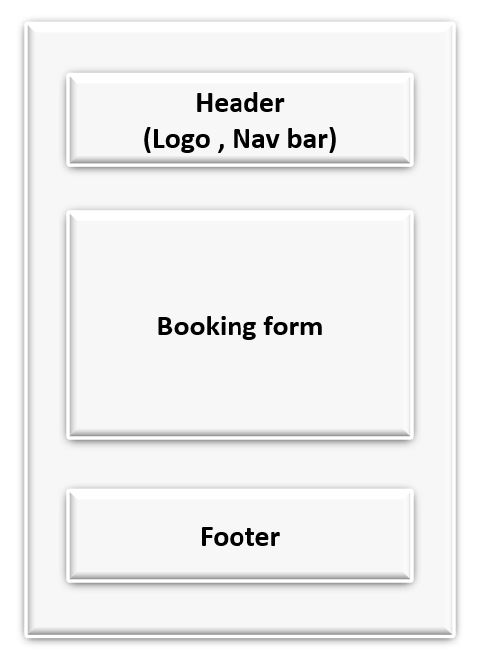

1. **Feedback**

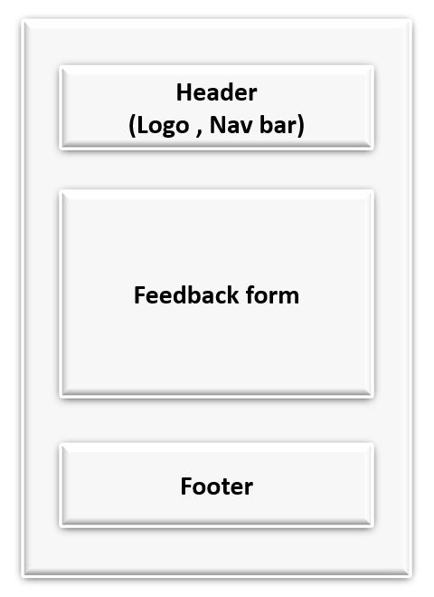

1. **Contact Us**

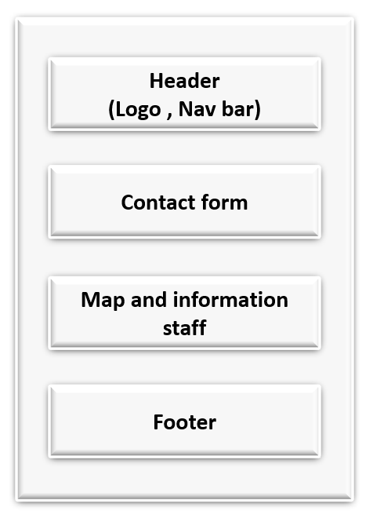

# TASK SHEET REVIEW 2

|  |  |  |  |  |  |  |  |
| --- | --- | --- | --- | --- | --- | --- | --- |
| **Project Ref. No.:**  **eP/Advertisement Portal Management**  **System/01** | | **Project Title:** | **Activity Plan Prepared By:** | **Date of Preparation of Activity Plan:** | | | |
| **Sr.**  **No.** | **Task** | **Actual**  **Start**  **Date** | **Actual Days** | **Team**  **Mate Names** | **Status** |
| 1 | Site Map | NEXUS AQUARIUM | Giu | 27-May-23 | 1 | Giu | Completed |
| 2 | Mock of the website | 27-May-23 | 2 | Giu | Completed |
| 3 | Task sheet | 27-May-23 | 2 | Nhan | Completed |

|  |  |
| --- | --- |
| **Date:** | |
| Signature of Instructor:  **Ms. Le Mong Thuy** | Signature of Team Leader:  **Phan Van Giu** |

**WEBSITE DESCRIPTION**

1. **Homepage**

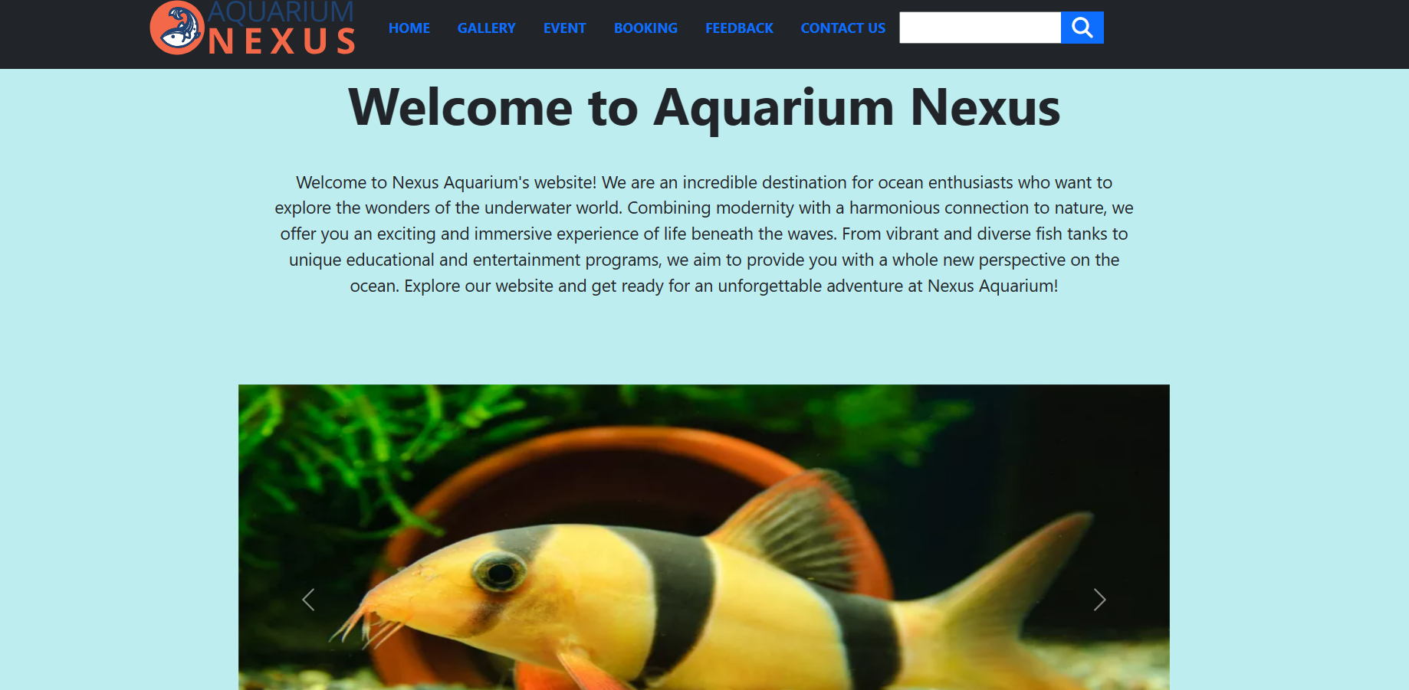

1. **Gallery**

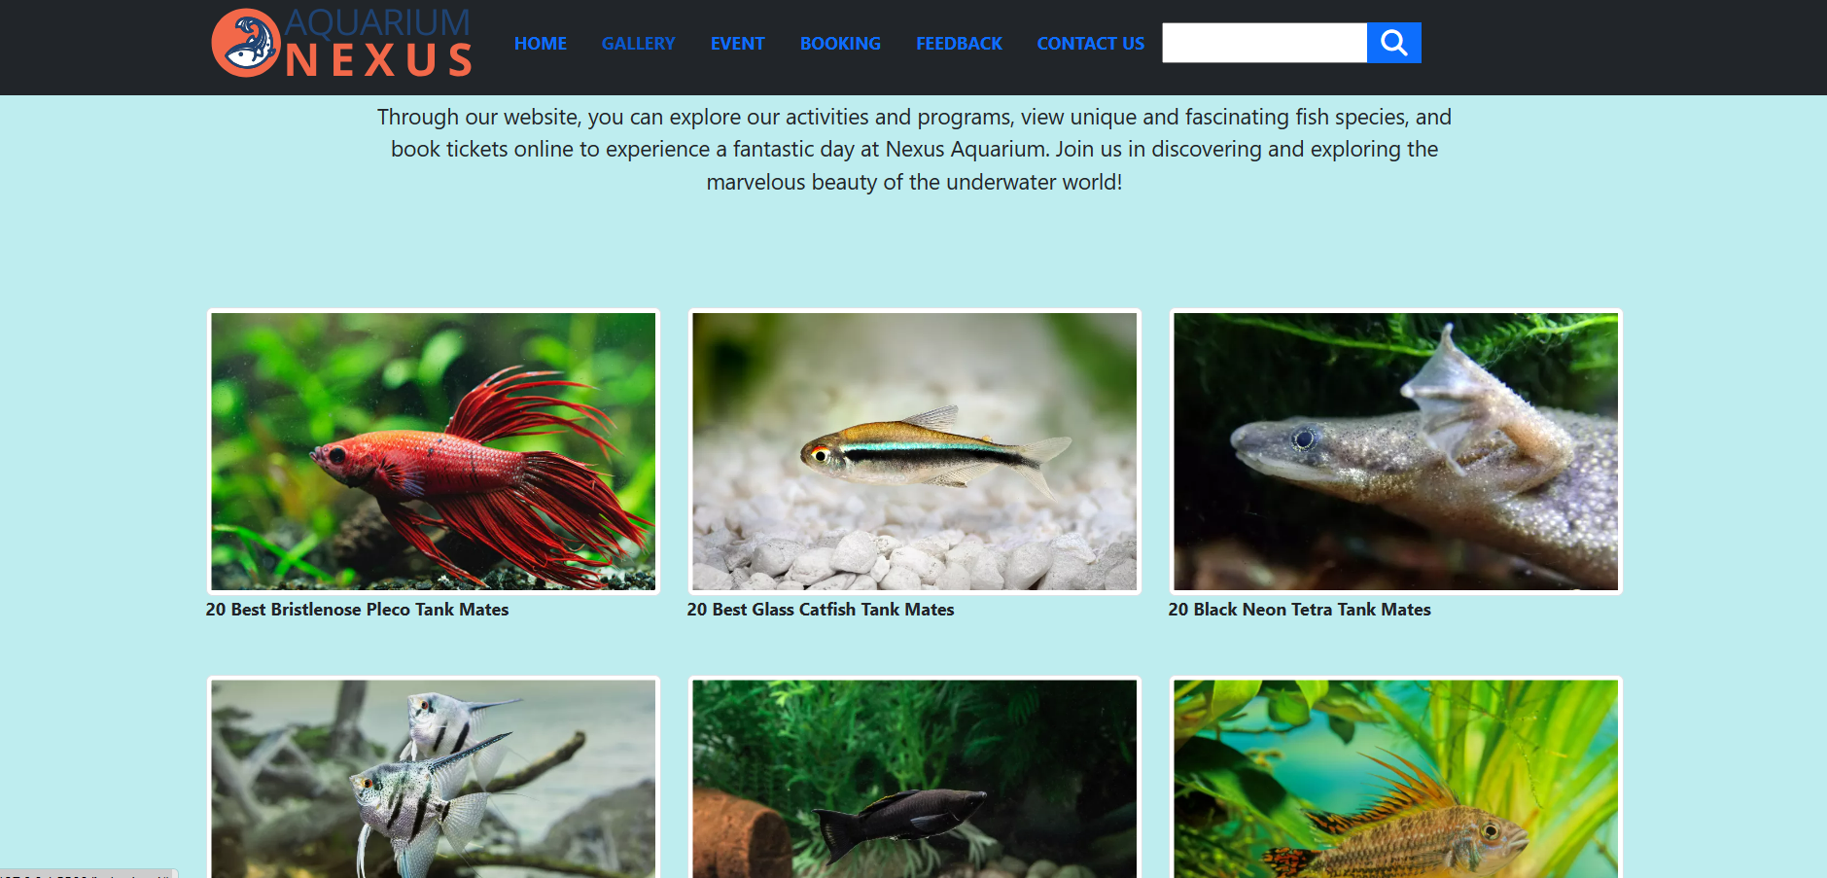

1. **Event**

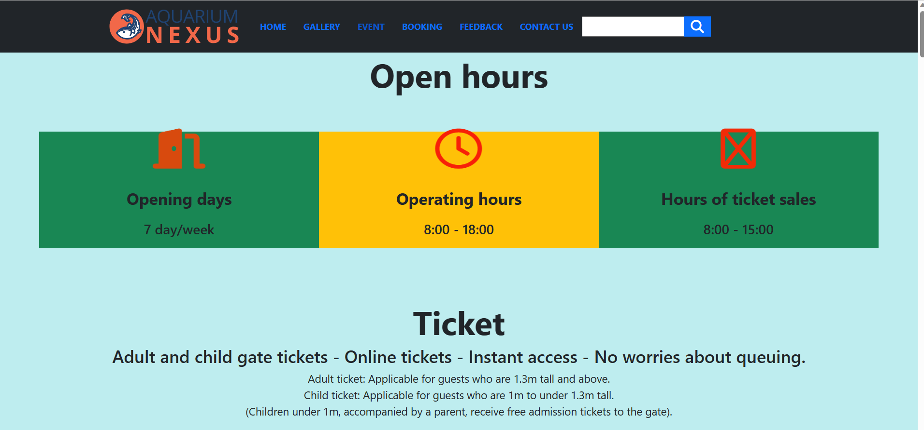

1. **Booking**

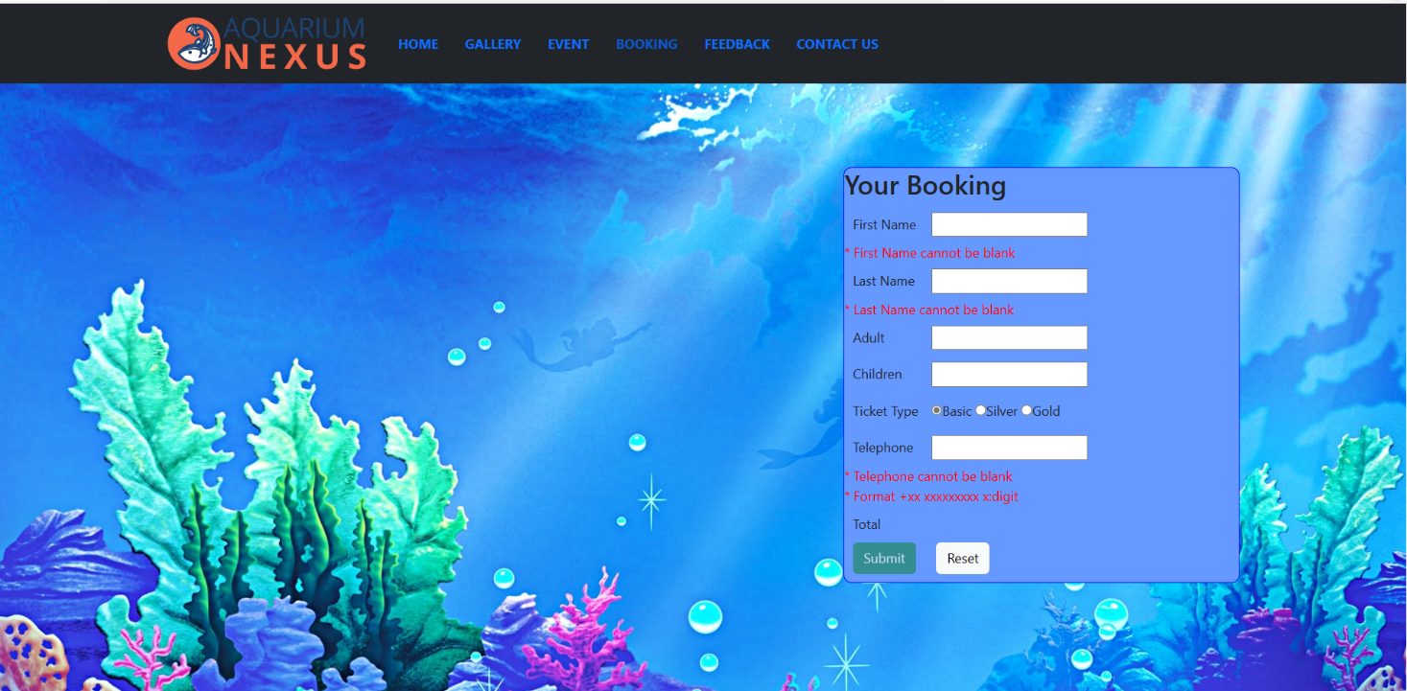

1. **Feedback**

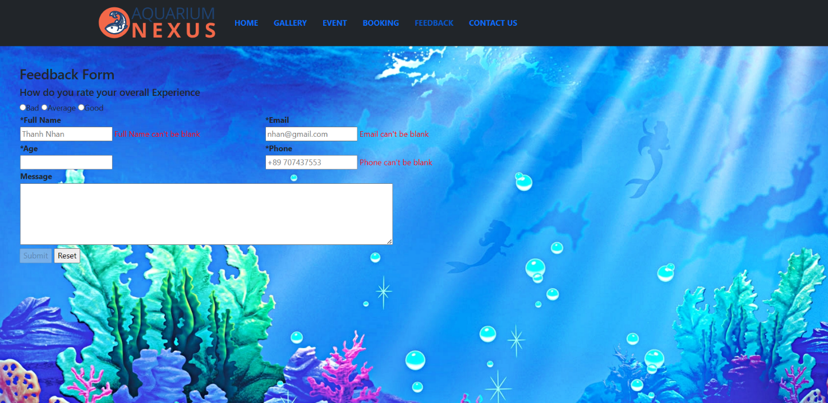

1. **Contact us**

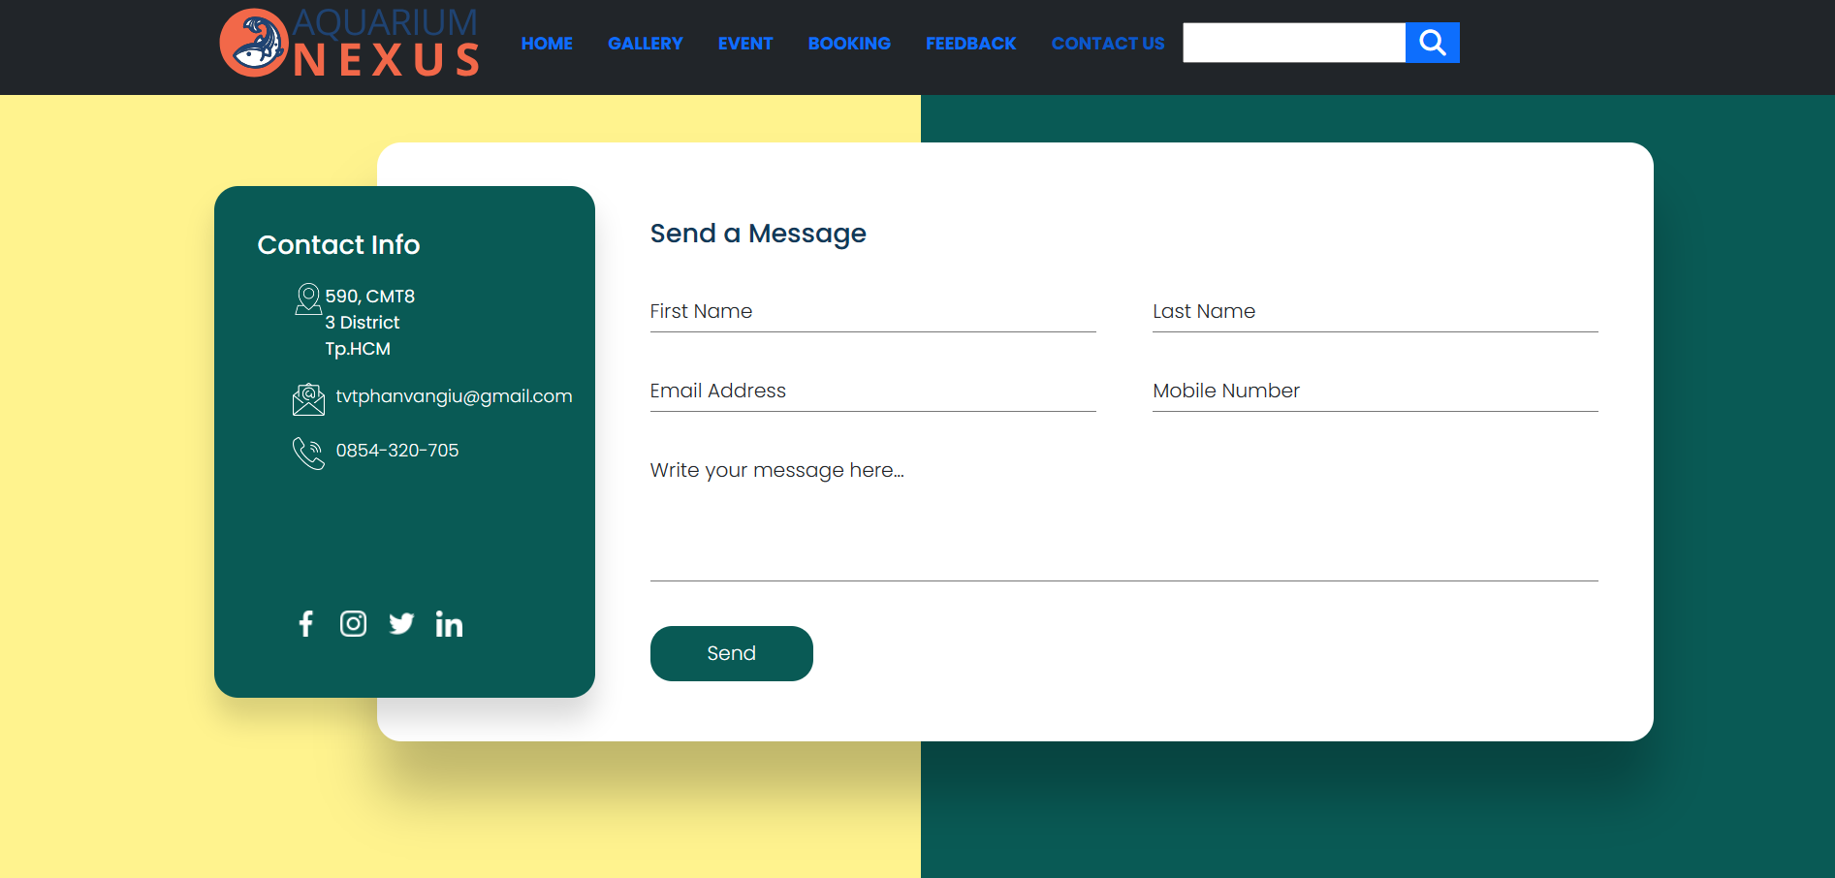

**JAVASCRIPT DESCRIPTION**

1. **Homepage**

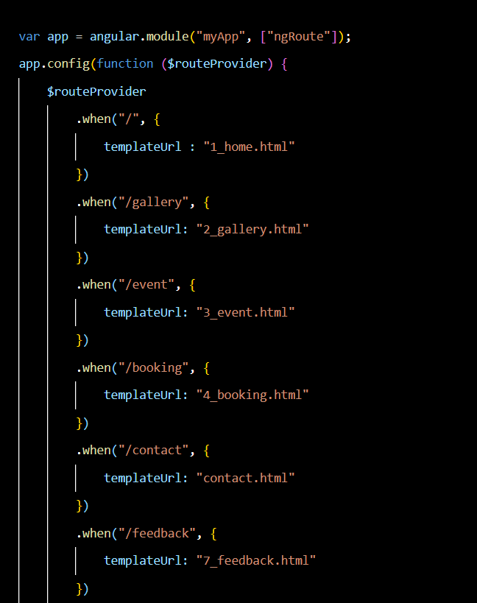

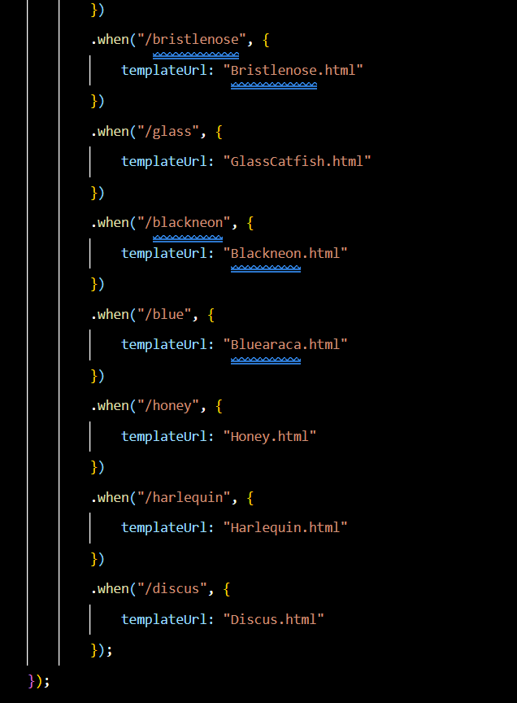

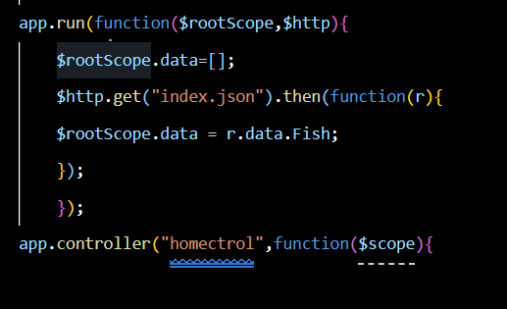

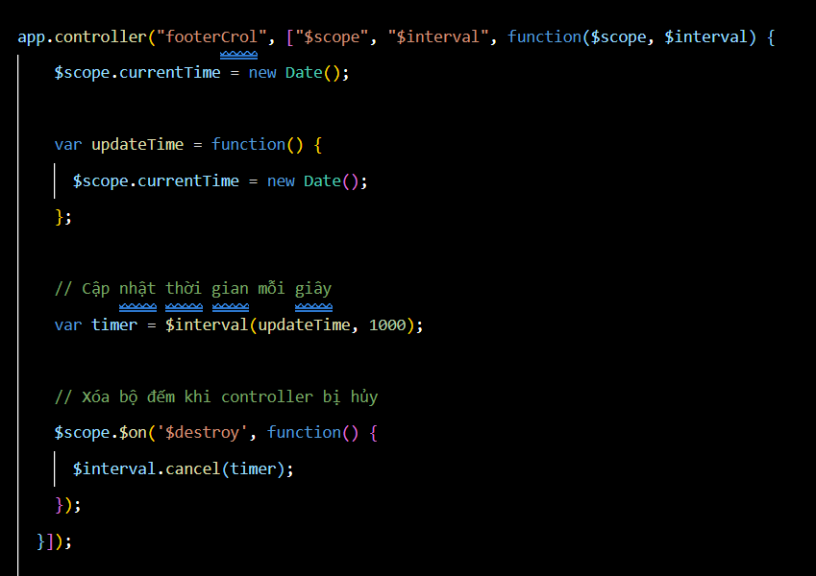

1. **Gallery**
2. **Event**
3. **Booking**

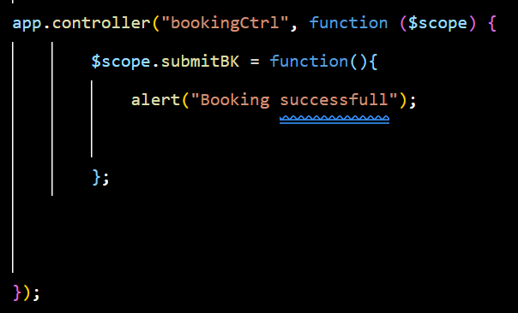

1. **Feedback**

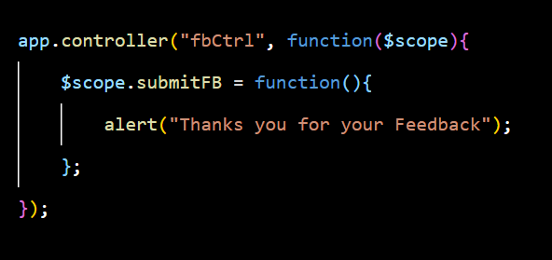

1. **Contact us**

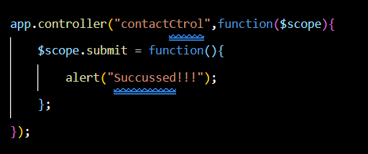

# TASK SHEET REVIEW 3

|  |  |  |  |  |  |  |  |  |  |
| --- | --- | --- | --- | --- | --- | --- | --- | --- | --- |
| **Project Ref. No.:**  **eP/Advertisement Portal Management**  **System/01** | | | **Project Title:** | **Activity Plan Prepared By:** | | **Date of Preparation of Activity Plan:** | | | |
| **Sr.**  **No.** | | **Task** | **Actual**  **Start**  **Date** | **Actual Days** | **Team**  **Mate Names** | **Status** |
| 1 | | Home Page | NEXUS AQUARIUM | Giu | | 20-June-23 | 1 | Giu | Completed |
| 2 | | Gallery | 20-June-23 | 3 | Giu | Completed |
| 3 | | Event | 20-June-23 | 2 | Giu | Completed |
| 4 | | Booking | 20-June-23 | 2 | Nhan | Completed |
| 5 | | Feedback | 20-June-23 | 2 | Nhan | Completed |
| 6 | | Contact us | 20-June-23 | 2 | Giu | Completed |
| **Date:** | | | | | | | | | |
| Signature of Instructor:  **Ms. Le Mong Thuy** | | | | Signature of Team Leader:  **Phan Van Giu** | | | | | |